Make Drupal Carousel

Note: This guide assumes the Drupal project is configured. “PEP CCMP Bootstrap5” theme, “PEP Home” and “PEP Project Tracking” modules should be installed.

If not, please read “Configure running project” first.

## A] Install Carousel

To install “Bootstrap Simple Carousel” module, go to the admin menu above and click on “Extend”



Since this repository also has “Bootstrap Simple Carousel”, search “Carousel” into the search bar and there should be one result. Check the module: “Bootstrap Simple Carousel” and install the modules.

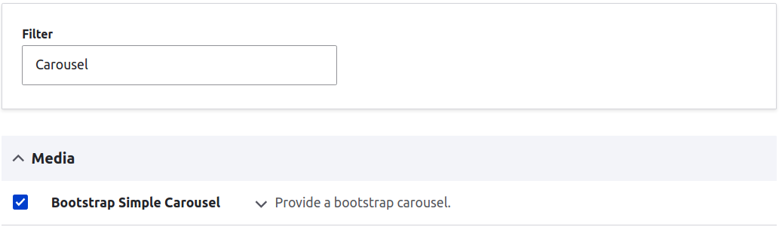

If the installation is successful, there should be a message for successful installation:

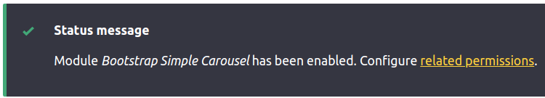

## B] Configure Carousel

Go to "Structure" admin menu



Click on "Bootstrap simple carousel items"



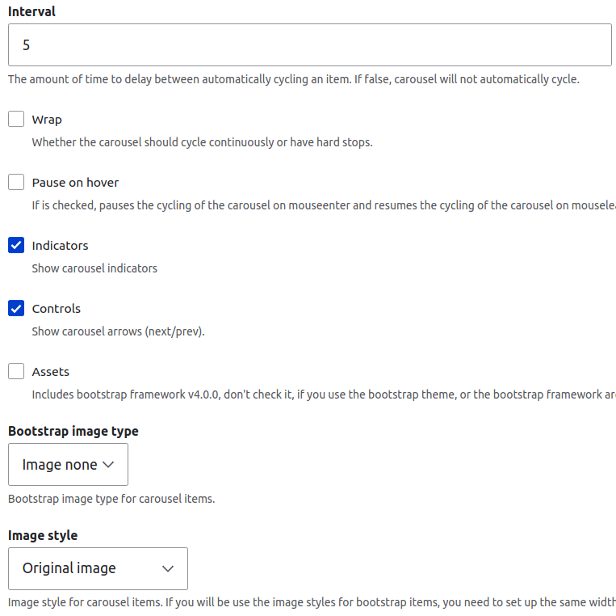Click on "Settings" button then input settings:

- set interval (in unit of seconds)

- check "Indicator"

- check "Controls"

- click "Save configuration" button

(Picture shown on the right of this text)

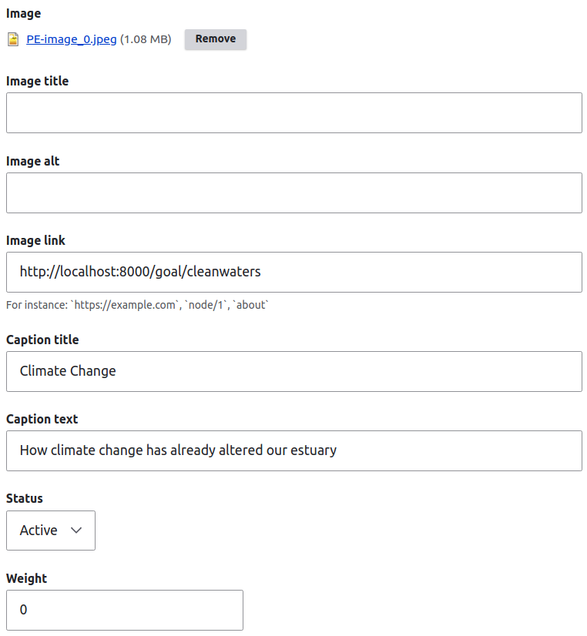

C] Add content to carousel

Go to "Structure" admin menu and click on "Bootstrap simple carousel items" again

This time, click on "Add element" button and fill in a form for each image inserted

(make sure to set Status to 'Active')

If done correctly, there should be a single row of content displayed:

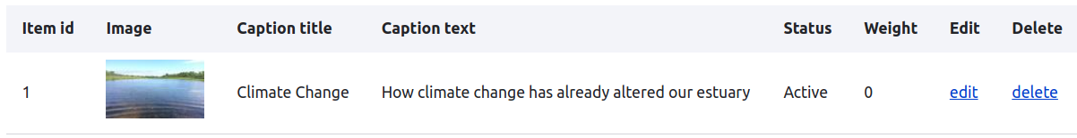

To modify the carousel content in the future, each row can be edited and deleted.

D] Render carousel on a page

Go to "Structure" admin menu but this time, click on "Block layout":



Scroll down to "Main content" section and click on "Place block" button



Find "Bootstrap simple carousel block" and click on "Place block" button



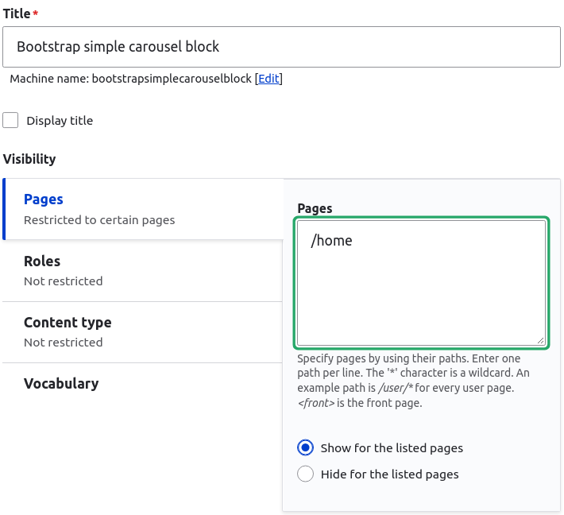

In "Configure block" section, apply settings:

- uncheck "Display title"

- in "Visibility" section, click on "Pages", type in "/home" in the text box

- click on "Save block".

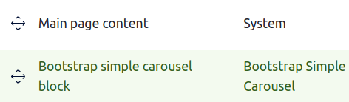"Bootstrap simple carousel block" Block should be created.

Click and drag the created block to the above "Main page content" block

and click on “Save blocks” at the bottom of the page:

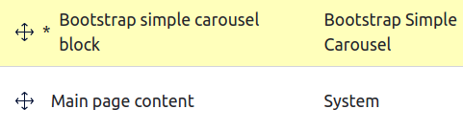

Fin] Check the result

On admin menu, click on "Back to site" and there should be a carousel in the landing page!

The carousel should have:

* Arrow buttons to move to a different slide
* Indicators at the bottom of the carousel
* Clickable images that point to different pages